**Land Down Under – Men at Work**

Marty Z <http://www.youtube.com/watch?v=T_8YEIqJYks>

<https://www.youtube.com/watch?v=-NNQlU1aF1Y>

Verse: (reggae style)

***3x:***

**Bm A Bm GA (2x) intro/extra**

**Bm A Bm GA (4x) verse**

**D A Bm GA (4x) chorus**

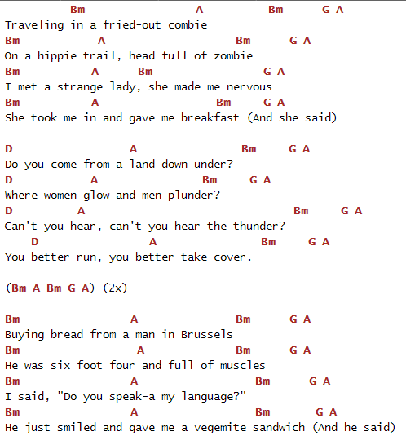

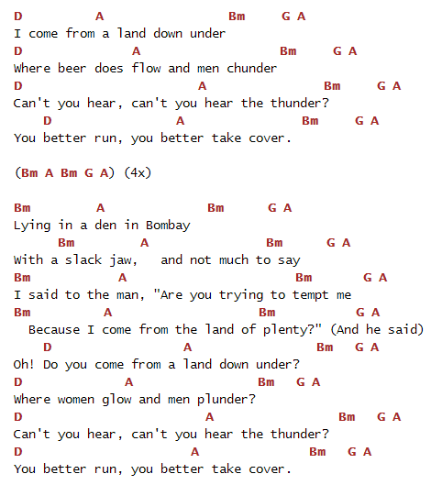

#Based upon the acoustic version. Figured it out from the video. Sounds good to me atleast.#

<http://www.youtube.com/watch?v=cRyKCJUXehM>

Capo II

[Am](http://www.guitaretab.com/m/men-at-work/291733.html) [G](http://www.guitaretab.com/m/men-at-work/291733.html)(Stop); [Am](http://www.guitaretab.com/m/men-at-work/291733.html) [F](http://www.guitaretab.com/m/men-at-work/291733.html) [G](http://www.guitaretab.com/m/men-at-work/291733.html) 2x

[Am](http://www.guitaretab.com/m/men-at-work/291733.html) [G](http://www.guitaretab.com/m/men-at-work/291733.html) [Am](http://www.guitaretab.com/m/men-at-work/291733.html) [F](http://www.guitaretab.com/m/men-at-work/291733.html) [G](http://www.guitaretab.com/m/men-at-work/291733.html)

Traveling in a fried-out combie

[Am](http://www.guitaretab.com/m/men-at-work/291733.html) [G](http://www.guitaretab.com/m/men-at-work/291733.html) [Am](http://www.guitaretab.com/m/men-at-work/291733.html) [F](http://www.guitaretab.com/m/men-at-work/291733.html) [G](http://www.guitaretab.com/m/men-at-work/291733.html)

On a hippie trail, head full of zombie

[Am](http://www.guitaretab.com/m/men-at-work/291733.html) [G](http://www.guitaretab.com/m/men-at-work/291733.html) [Am](http://www.guitaretab.com/m/men-at-work/291733.html) [F](http://www.guitaretab.com/m/men-at-work/291733.html) [G](http://www.guitaretab.com/m/men-at-work/291733.html)

I met a strange lady, she made me nervous

[Am](http://www.guitaretab.com/m/men-at-work/291733.html) [G](http://www.guitaretab.com/m/men-at-work/291733.html) [Am](http://www.guitaretab.com/m/men-at-work/291733.html)

She took me in and gave me breakfast

[F](http://www.guitaretab.com/m/men-at-work/291733.html) [G](http://www.guitaretab.com/m/men-at-work/291733.html)

And she said

[C](http://www.guitaretab.com/m/men-at-work/291733.html) [G](http://www.guitaretab.com/m/men-at-work/291733.html) [Am](http://www.guitaretab.com/m/men-at-work/291733.html) [F](http://www.guitaretab.com/m/men-at-work/291733.html) [G](http://www.guitaretab.com/m/men-at-work/291733.html)

Do you come from a land down under?

[C](http://www.guitaretab.com/m/men-at-work/291733.html) [G](http://www.guitaretab.com/m/men-at-work/291733.html) [Am](http://www.guitaretab.com/m/men-at-work/291733.html) [F](http://www.guitaretab.com/m/men-at-work/291733.html) [G](http://www.guitaretab.com/m/men-at-work/291733.html)

Where women glow and men plunder?

[C](http://www.guitaretab.com/m/men-at-work/291733.html) [G](http://www.guitaretab.com/m/men-at-work/291733.html) [Am](http://www.guitaretab.com/m/men-at-work/291733.html) [F](http://www.guitaretab.com/m/men-at-work/291733.html) [G](http://www.guitaretab.com/m/men-at-work/291733.html)

Can t you hear, can t you hear the thunder?

[C](http://www.guitaretab.com/m/men-at-work/291733.html) [G](http://www.guitaretab.com/m/men-at-work/291733.html) [Am](http://www.guitaretab.com/m/men-at-work/291733.html) [F](http://www.guitaretab.com/m/men-at-work/291733.html) [G](http://www.guitaretab.com/m/men-at-work/291733.html)

You better run, you better take cover.

[Am](http://www.guitaretab.com/m/men-at-work/291733.html) [G](http://www.guitaretab.com/m/men-at-work/291733.html) [Am](http://www.guitaretab.com/m/men-at-work/291733.html) [F](http://www.guitaretab.com/m/men-at-work/291733.html) [G](http://www.guitaretab.com/m/men-at-work/291733.html)

Buying bread from a man in Brussels

[Am](http://www.guitaretab.com/m/men-at-work/291733.html) [G](http://www.guitaretab.com/m/men-at-work/291733.html) [Am](http://www.guitaretab.com/m/men-at-work/291733.html) [F](http://www.guitaretab.com/m/men-at-work/291733.html) [G](http://www.guitaretab.com/m/men-at-work/291733.html)

He was six foot four and full of muscles

[Am](http://www.guitaretab.com/m/men-at-work/291733.html) [G](http://www.guitaretab.com/m/men-at-work/291733.html) [Am](http://www.guitaretab.com/m/men-at-work/291733.html) [F](http://www.guitaretab.com/m/men-at-work/291733.html) [G](http://www.guitaretab.com/m/men-at-work/291733.html)

I said, do you speak-a my language?

[Am](http://www.guitaretab.com/m/men-at-work/291733.html) [G](http://www.guitaretab.com/m/men-at-work/291733.html) [Am](http://www.guitaretab.com/m/men-at-work/291733.html)

He just smiled and gave me a vegemite sandwich

[F](http://www.guitaretab.com/m/men-at-work/291733.html) [G](http://www.guitaretab.com/m/men-at-work/291733.html)

And he said

[ Tab from: http://www.guitaretab.com/m/men-at-work/291733.html ]

[C](http://www.guitaretab.com/m/men-at-work/291733.html) [G](http://www.guitaretab.com/m/men-at-work/291733.html) [Am](http://www.guitaretab.com/m/men-at-work/291733.html) [F](http://www.guitaretab.com/m/men-at-work/291733.html) [G](http://www.guitaretab.com/m/men-at-work/291733.html)

Do you come from a land down under?

[C](http://www.guitaretab.com/m/men-at-work/291733.html) [G](http://www.guitaretab.com/m/men-at-work/291733.html) [Am](http://www.guitaretab.com/m/men-at-work/291733.html) [F](http://www.guitaretab.com/m/men-at-work/291733.html) [G](http://www.guitaretab.com/m/men-at-work/291733.html)

Where women glow and men plunder?

[C](http://www.guitaretab.com/m/men-at-work/291733.html) [G](http://www.guitaretab.com/m/men-at-work/291733.html) [Am](http://www.guitaretab.com/m/men-at-work/291733.html) [F](http://www.guitaretab.com/m/men-at-work/291733.html) [G](http://www.guitaretab.com/m/men-at-work/291733.html)

Can t you hear, can t you hear the thunder?

[C](http://www.guitaretab.com/m/men-at-work/291733.html) [G](http://www.guitaretab.com/m/men-at-work/291733.html) [Am](http://www.guitaretab.com/m/men-at-work/291733.html) [F](http://www.guitaretab.com/m/men-at-work/291733.html) [G](http://www.guitaretab.com/m/men-at-work/291733.html)

You better run, you better take cover.

[Am](http://www.guitaretab.com/m/men-at-work/291733.html) [G](http://www.guitaretab.com/m/men-at-work/291733.html) [Am](http://www.guitaretab.com/m/men-at-work/291733.html) [F](http://www.guitaretab.com/m/men-at-work/291733.html) [G](http://www.guitaretab.com/m/men-at-work/291733.html)

Lying in a den in Bombay

[Am](http://www.guitaretab.com/m/men-at-work/291733.html) [G](http://www.guitaretab.com/m/men-at-work/291733.html) [Am](http://www.guitaretab.com/m/men-at-work/291733.html) [F](http://www.guitaretab.com/m/men-at-work/291733.html) [G](http://www.guitaretab.com/m/men-at-work/291733.html)

With a slack jaw, and not much to say

[Am](http://www.guitaretab.com/m/men-at-work/291733.html) [G](http://www.guitaretab.com/m/men-at-work/291733.html) [Am](http://www.guitaretab.com/m/men-at-work/291733.html) [F](http://www.guitaretab.com/m/men-at-work/291733.html) [G](http://www.guitaretab.com/m/men-at-work/291733.html)

I said to the man, are you trying to tempt me

[Am](http://www.guitaretab.com/m/men-at-work/291733.html) [G](http://www.guitaretab.com/m/men-at-work/291733.html) [Am](http://www.guitaretab.com/m/men-at-work/291733.html)

Because I come from the land of plenty?

[F](http://www.guitaretab.com/m/men-at-work/291733.html) [G](http://www.guitaretab.com/m/men-at-work/291733.html)

And he said

[C](http://www.guitaretab.com/m/men-at-work/291733.html) [G](http://www.guitaretab.com/m/men-at-work/291733.html) [Am](http://www.guitaretab.com/m/men-at-work/291733.html) [F](http://www.guitaretab.com/m/men-at-work/291733.html) [G](http://www.guitaretab.com/m/men-at-work/291733.html)

Oh! do you come from a land down under? (oh yeah yeah)

[C](http://www.guitaretab.com/m/men-at-work/291733.html) [G](http://www.guitaretab.com/m/men-at-work/291733.html) [Am](http://www.guitaretab.com/m/men-at-work/291733.html) [F](http://www.guitaretab.com/m/men-at-work/291733.html) [G](http://www.guitaretab.com/m/men-at-work/291733.html)

Where women glow and men plunder?

[C](http://www.guitaretab.com/m/men-at-work/291733.html) [G](http://www.guitaretab.com/m/men-at-work/291733.html) [Am](http://www.guitaretab.com/m/men-at-work/291733.html) [F](http://www.guitaretab.com/m/men-at-work/291733.html) [G](http://www.guitaretab.com/m/men-at-work/291733.html)

Can t you hear, can t you hear the thunder?

[C](http://www.guitaretab.com/m/men-at-work/291733.html) [G](http://www.guitaretab.com/m/men-at-work/291733.html) [Am](http://www.guitaretab.com/m/men-at-work/291733.html) [F](http://www.guitaretab.com/m/men-at-work/291733.html) [G](http://www.guitaretab.com/m/men-at-work/291733.html)

You better run, you better take cover.

[C](http://www.guitaretab.com/m/men-at-work/291733.html) [G](http://www.guitaretab.com/m/men-at-work/291733.html) [Am](http://www.guitaretab.com/m/men-at-work/291733.html) [F](http://www.guitaretab.com/m/men-at-work/291733.html) [G](http://www.guitaretab.com/m/men-at-work/291733.html)

Oh! do you come from a land down under? (oh yeah yeah)

[C](http://www.guitaretab.com/m/men-at-work/291733.html) [G](http://www.guitaretab.com/m/men-at-work/291733.html) [Am](http://www.guitaretab.com/m/men-at-work/291733.html) [F](http://www.guitaretab.com/m/men-at-work/291733.html) [G](http://www.guitaretab.com/m/men-at-work/291733.html)

Where women glow and men plunder?

[C](http://www.guitaretab.com/m/men-at-work/291733.html) [G](http://www.guitaretab.com/m/men-at-work/291733.html) [Am](http://www.guitaretab.com/m/men-at-work/291733.html) [F](http://www.guitaretab.com/m/men-at-work/291733.html) [G](http://www.guitaretab.com/m/men-at-work/291733.html)

Can t you hear, can t you hear the thunder?

[C](http://www.guitaretab.com/m/men-at-work/291733.html) [G](http://www.guitaretab.com/m/men-at-work/291733.html) [Am](http://www.guitaretab.com/m/men-at-work/291733.html) [F](http://www.guitaretab.com/m/men-at-work/291733.html) [G](http://www.guitaretab.com/m/men-at-work/291733.html)

You better run, you better take cover. . . .

* Alternate:

Open

[Am](http://www.guitaretab.com/m/men-at-work/291733.html) = [Bm](http://www.guitaretab.com/m/men-at-work/291733.html)

[G](http://www.guitaretab.com/m/men-at-work/291733.html) = [A](http://www.guitaretab.com/m/men-at-work/291733.html)

[F](http://www.guitaretab.com/m/men-at-work/291733.html) = [G](http://www.guitaretab.com/m/men-at-work/291733.html)

[C](http://www.guitaretab.com/m/men-at-work/291733.html) = [D](http://www.guitaretab.com/m/men-at-work/291733.html)